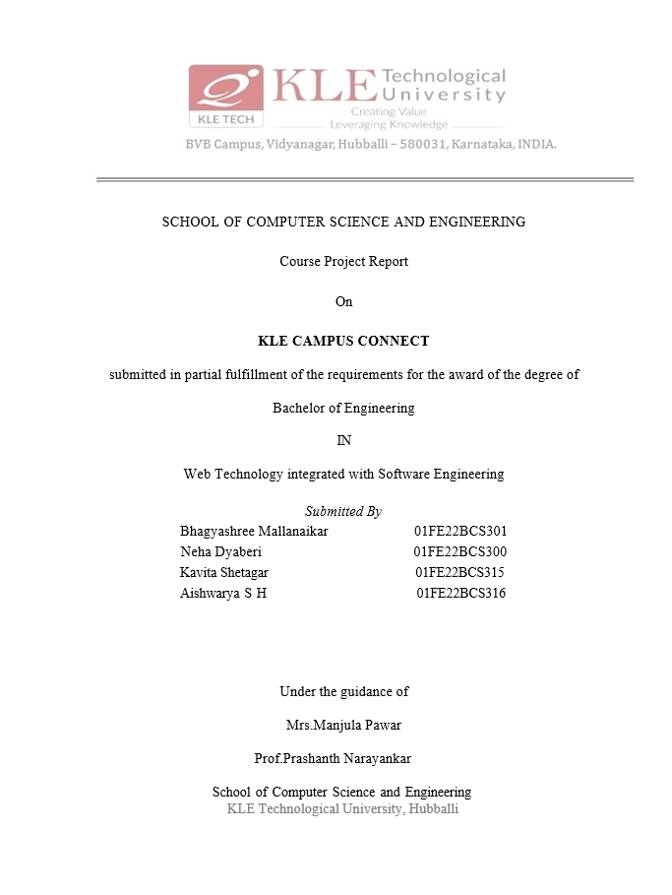

**CONTENTS:**

1. Introduction
2. Problem Statement
3. Objectives
4. Block Diagram
5. Functional and Non functional requirements
6. Modules
7. ER Diagram
8. Database Description

**1. Introduction**

**Campus Connect** is an intuitive online platform designed to bridge the gap between students and campus organizations. It serves as a one-stop solution for students to explore various clubs, stay informed about upcoming events, and connect with peers who share similar interests. By fostering student engagement, this platform enriches the campus experience and promotes a sense of community.

**2.Problem statement**

Students often struggle to discover campus clubs and activities that align with their interests. Information about these clubs and events is scattered across multiple sources, making it difficult to stay updated. "Campus Connect" aims to solve this by creating a centralized platform where students can easily find and engage with clubs, events, and networking opportunities.

**3.Objectives**

* To centralize information about campus and activities for easy access.
* To provide a user-friendly interface for discovering events and networking opportunities.
* To enhance student participation in extracurricular activities.
* To enable club administrators to manage their information effectively.

**4.Block Diagram**

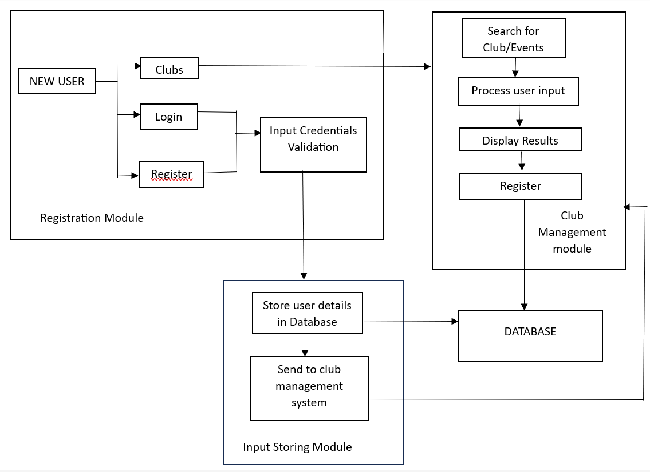

**5.a. Functional Requirements**

* Students can search and filter events by club, date, or category.
* Clubs can add, update, or delete event information.
* Real-time notifications are sent to subscribed users.
* User authentication and role management for students and admins.

**5.b. Non Functional Requirements**

* The platform should be scalable to handle thousands of users simultaneously.
* Notifications should be delivered within 5 seconds of event creation/update.
* The system should ensure data security for user and club information.
* The interface should be responsive for both desktop and mobile devices.

**6. Modules**

**6.a.Home page**



**b. Registration Page**

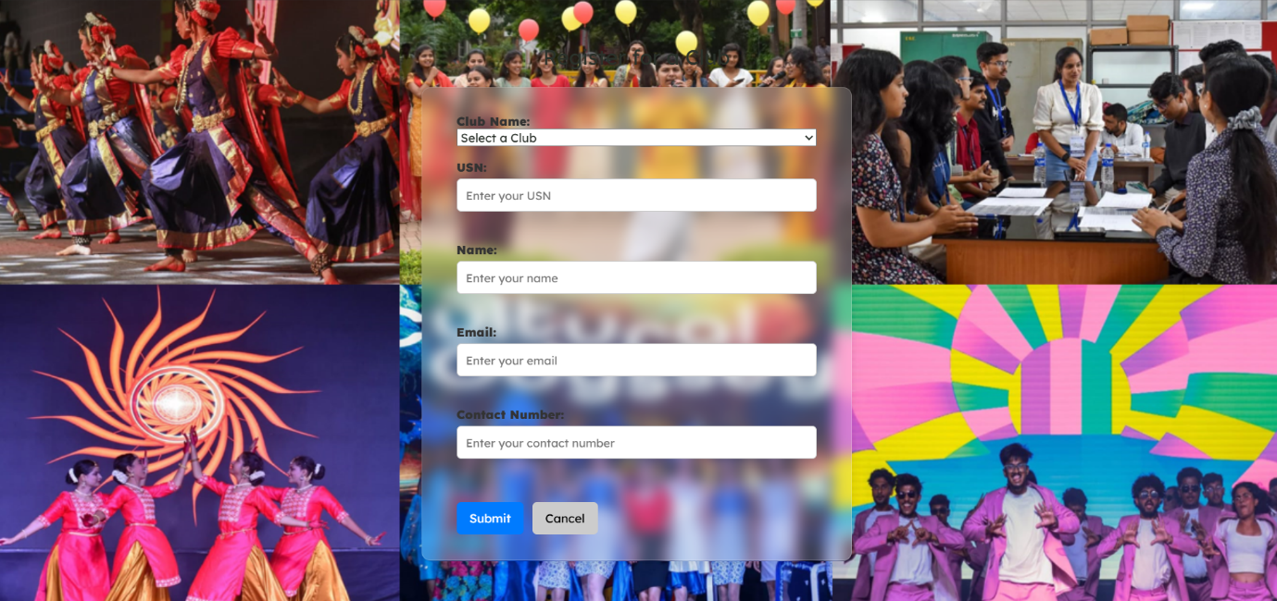

**c. Login Page**

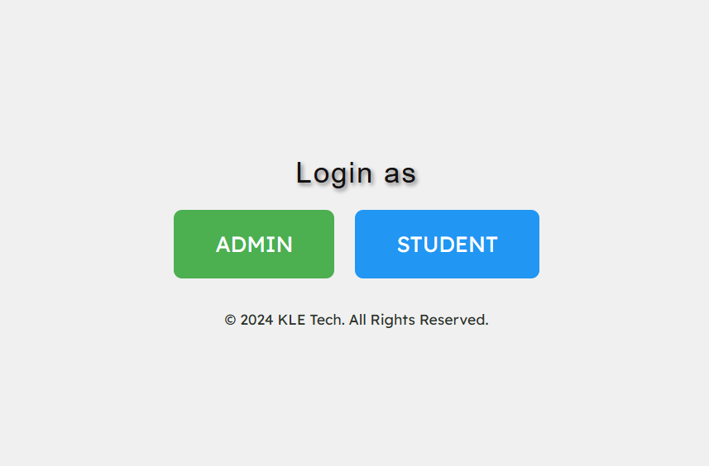

**d. Clubs Page**

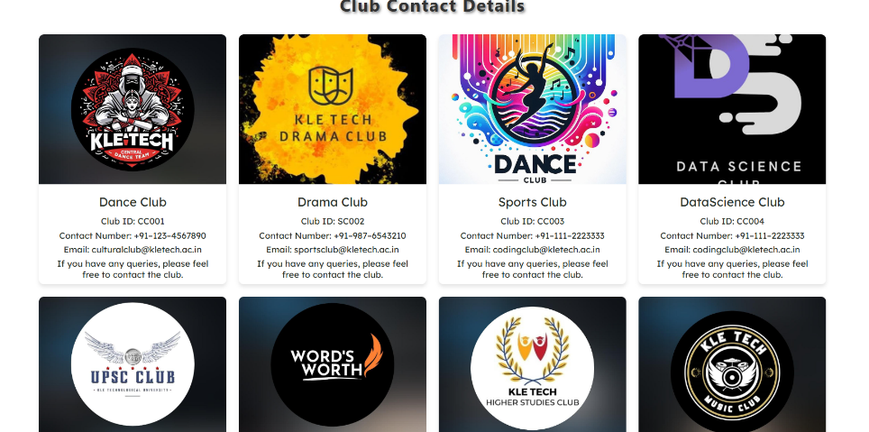

**7. ER Diagram**

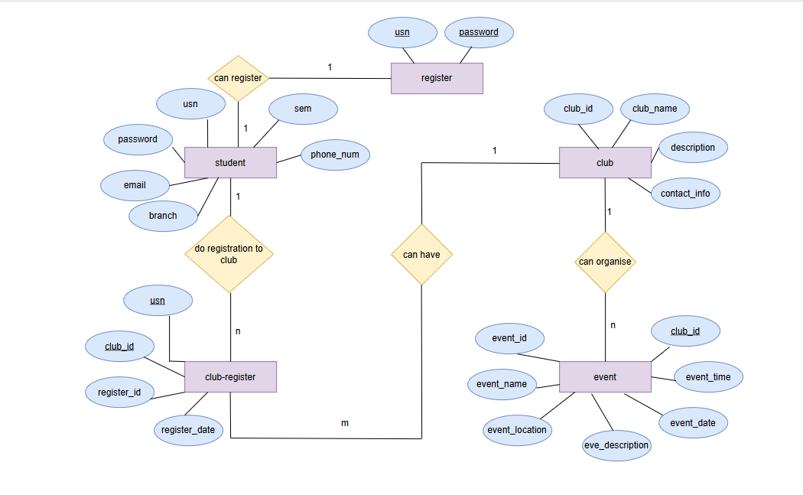**8.Data Description**

Database : MySQL

A MySQL database for "Campus Connect" can be structured to efficiently manage information about student clubs, events, user profiles, and interactions.

* Organized Data Structure: MySQL’s relational model links users, clubs, events, and activities in well-structured tables, enabling seamless data organization and retrieval.
* Advanced Search and Filtering: SQL queries facilitate efficient searching and filtering of clubs and events based on interests, categories, or other criteria.
* Secure User Management: MySQL supports secure authentication and role-based permissions, ensuring only authorized access to sensitive data.
* Scalability for High Usage: MySQL can handle growing datasets and high user traffic, maintaining performance as the platform scales.
* Data Consistency and Security: MySQL ensures reliable data management with ACID compliance and safeguards user data through encryption and permission controls.